1. First, we created the neon cloud PostgreSQL from vercel.
2. Then we installed Prisma as dev dependency.



1. Then created the Prisma schema using



1. And configured the env with database URL that we got from vercel.
2. Now, we create the model in the file created by 3.

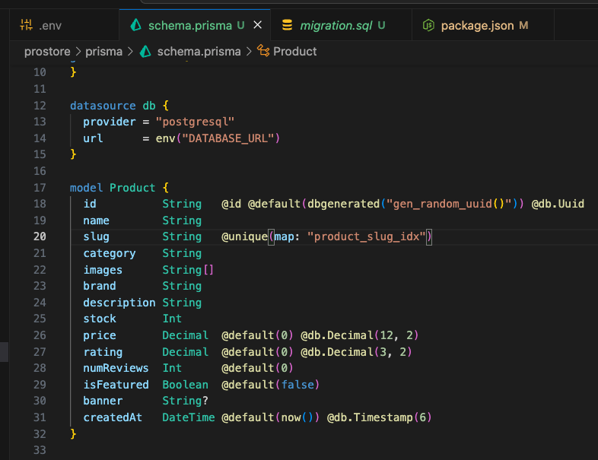

1. We then, create a script to make client

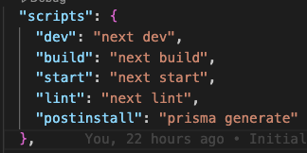 the last one.

1. Then we run it in our terminal using NPX

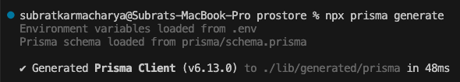

1. And now we can create and run migrations using this command



1. After that we can see the migrations, it created with name as INIT, which we gave

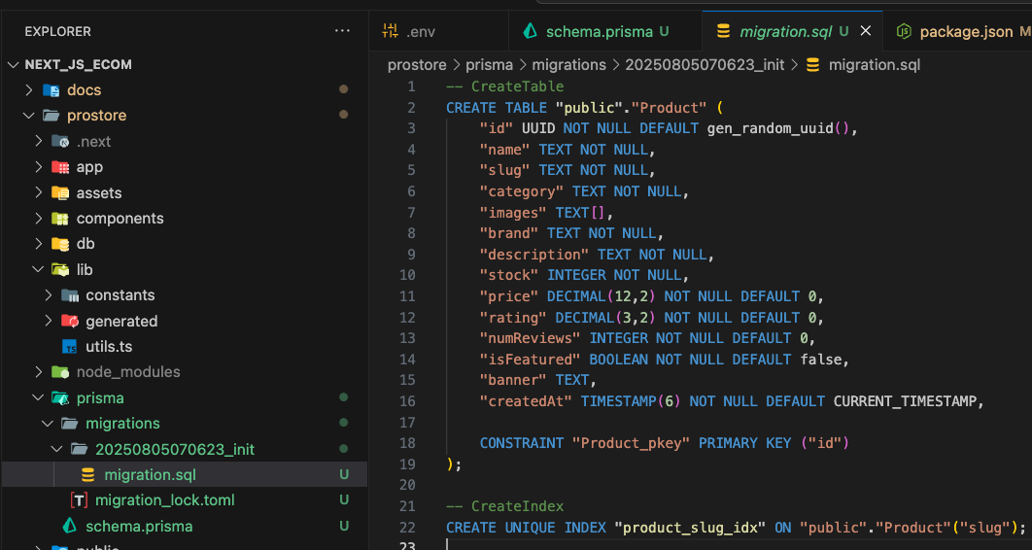

* To check this, we can use PG admin. But we will use Prisma studio just by running

